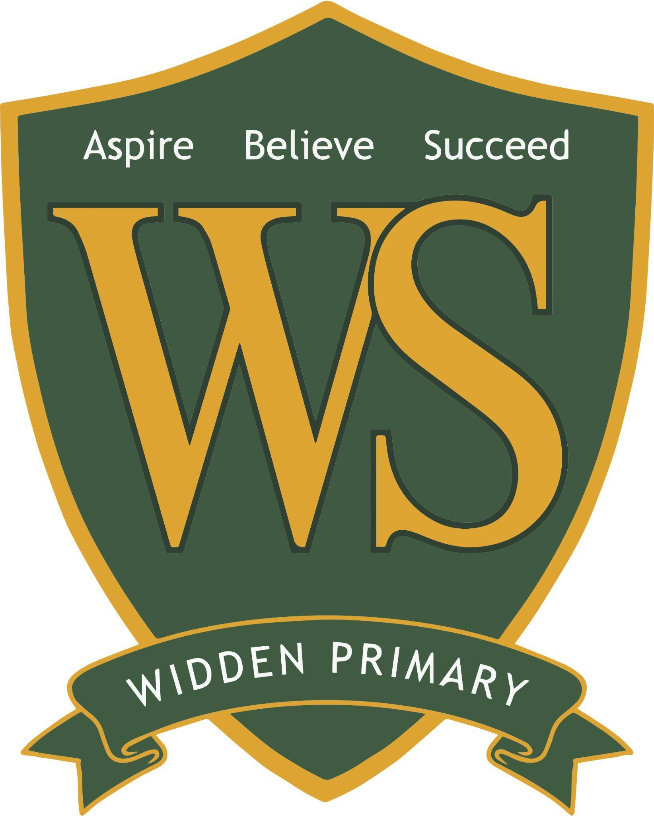
Free School Meals: Changes from September 2026

From September 2026, the government is expanding eligibility for Free School Meals to include more families receiving Universal Credit.

If your child currently receives free school meals, it is critical that you are registered on our online portal to ensure there is no interruption to their provision.

Whether your child decides to take these meals or not, the school may also receive additional funding for each eligible student. At a time when school budgets are very tight, this funding makes a real difference to the school – and all the funding is required to be spent on supporting disadvantaged students.

We have therefore invested in an online platform to make this process much simpler, and we would be very grateful if you could take two minutes to register.

What information do you need?

All that you will need is the following:
- Your own name and date of birth
- Contact details
- National Insurance Number (or National Asylum Seekers Number)
- Child's name and date of birth
- School your child is attending/will attend.

We would be very grateful if you could fill in your details on this Greenshaw Learning Trust OFSM application form (unless you have already registered), even if you believe you are not entitled to additional funding. The system re-checks details every week, and will automatically update our records if your status changes. Please note that an application must be completed for each child you have in our school.

My child currently receives a free school meal, do I need to reapply?

To ensure your child’s meal provision continues without interruption, and if you have not registered using the above link, please do so as soon as possible.

If you would like help with applying, you are very welcome to come into school and we would be happy to assist you with an application.

